**Science**

How we classify plants and animals based on similarities and differences.

Skeleton and muscles- why are they important and do all animals have the same skeleton?

**RE**

Why do Hindus try to be good- part 2

What matters most to Humanists and Christians?

**PE**

Year 3 and 4 swimming

Athletics

Orienteering

Individual sports led by Go Active

**Music**

Blackbird- listen to and appraise songs by the Beatles, begin to improvise along with instruments.

Reflect, rewind and replay- listen to, appraise and improvise along to classical music.

**Computing**

Online safety

Systems and searching-using search engines and understanding how results are ranked.

Video editing and using digital media.

**English**

The Tyger by William Blake- poetry

Non-Chronological reports on animals

Newspaper reports based on Charlotte’s Web

Diary writing based on Varjak Paw

**Art**

**What is still life and how has it changed in relation to modern art with a focus on Surrealism.**

How do artists use sketchbooks to help their art process.

**DT**

Cooking and tasting local produce to develop an understanding of how nutrition is important

**PSHE**

**Relationships*-*** exploring feelings in relationships such as jealousy, love, loss and falling out.

**Changing Me**- understanding how my body changes as I get older and why these changes are necessary so we can make babies when we grow up.

**VIPERS/ Reading**

SATs preparation for reading tests

The Catch- Animated short story

Farming and Agriculture- Non-Fiction text

Charlotte’s Web- E.B White

Varjak Paw- S.F Said

Varmint-Helen Ward

**Humanities**

How has fishing and farming changed in Cornwall, exploring innovation in agriculture.

**Geography**

A study to explore the land use in St Mawes and the surrounding area with a focus on how sustainable agriculture is in Cornwall.

**History**

A study of how fishing and farming has changed since early settlers began living in Cornwall.

Visit to Heligan gardens

**The Circle of Life**

**Sail Class Summer Term 2024**

**Maths**

SATs revision

Properties of Shape

Position, direction and coordinates

Time

Ratio

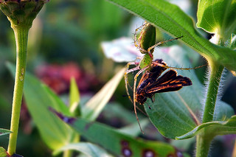

[This Photo](https://www.flickr.com/photos/ception/224680103) by Unknown Author is licensed under [CC BY-NC-ND](https://creativecommons.org/licenses/by-nc-nd/3.0/)